**Section 0**

* Section 0-Use GIT as local VCS. Steps to follow:
* 1. Create a directory 'project_dir' & cd to 'project_dir".
* 2. Initialize git version database. (git in it)
* 3. Create a new file index.html.
* 4. Check the git status. You should find index.html as untracked file.
* 5. Stage the index.html file.
* 6.Commit index.html
* 7. Make few changes in index.html & create a new file info.txt file.
* 8. Check git status. You should find index.html & info.txt as untracked files

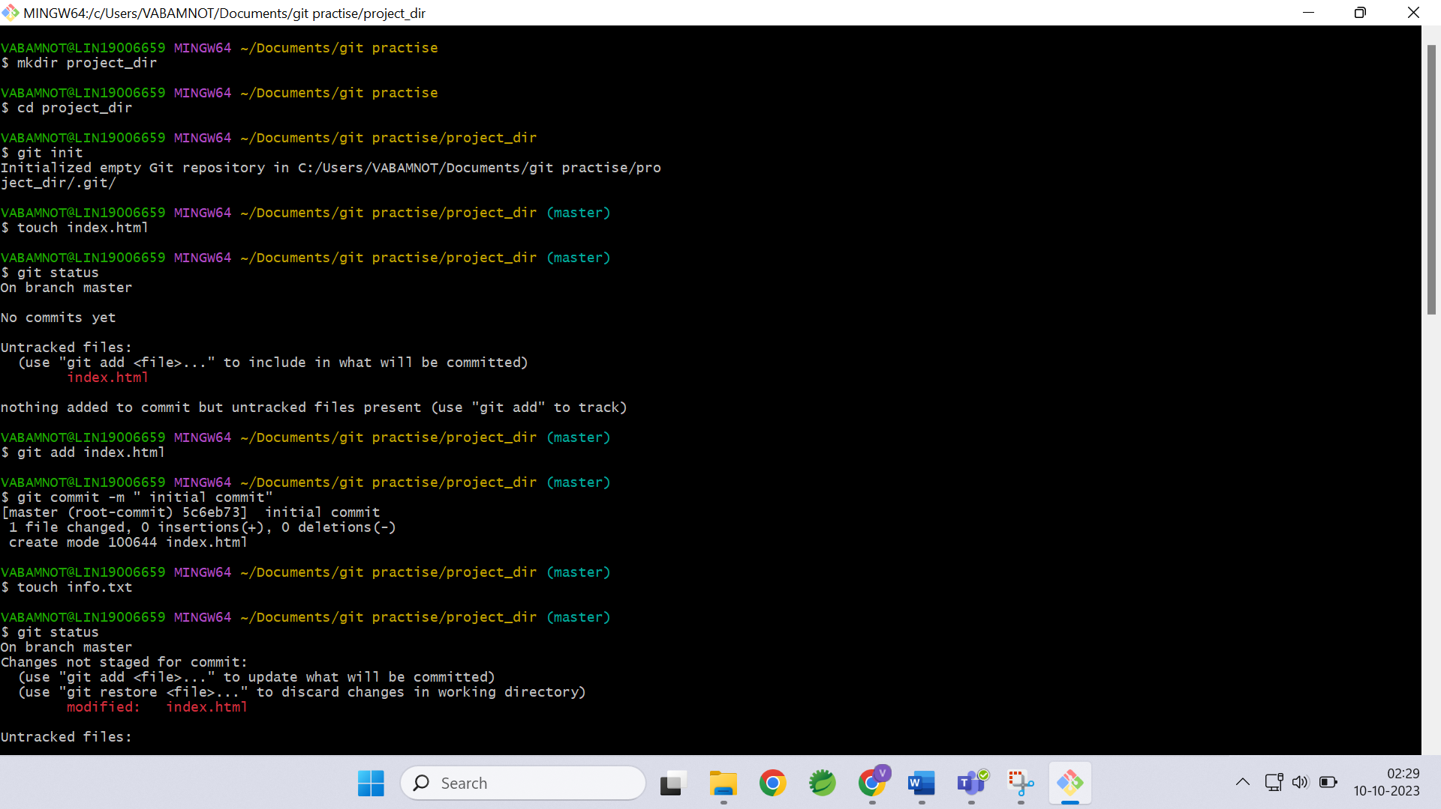

9. Configure GIT to ignore all txt files.

10. Again check the git status. You should find only index.html as untracked file.

11. State & commit index.html

12. Log all your comments so far.

Steps 13: Made some changes to index.html

14. Revert the change made in the previous step using git command.

15. Again change index.html.

16. Stage index.html.

